A000-Eur-Constantinople-Cross-Pendant-Bifurcate-Bronze-ΑΏΧΡ-500 CE

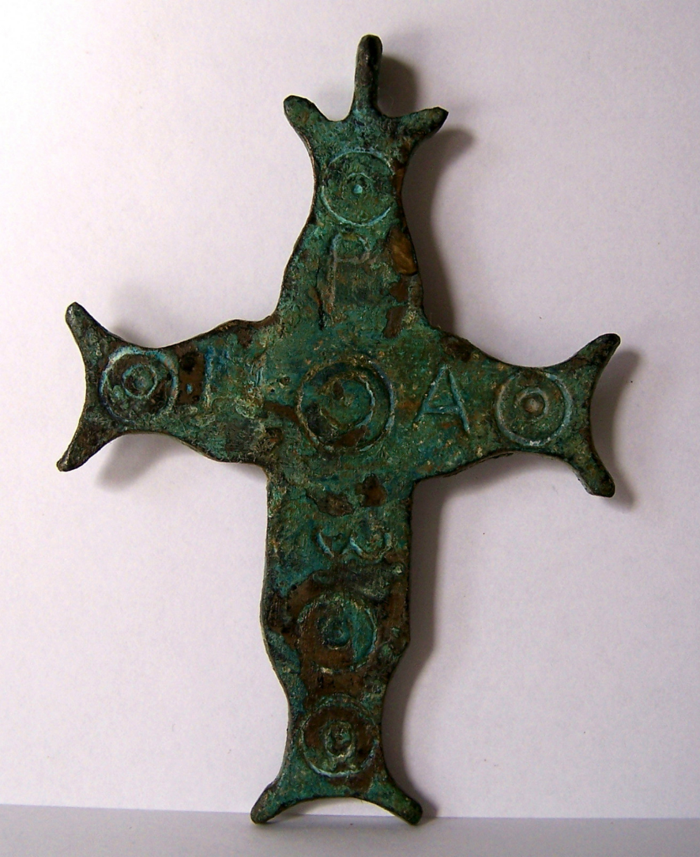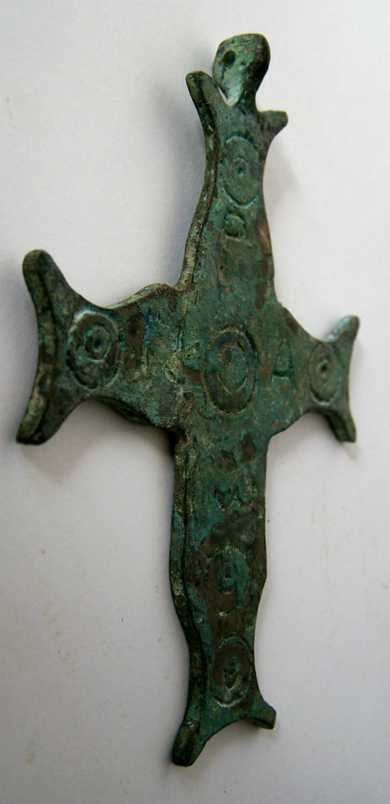

Figs. 1-2. Constantinople-Cross-Pendant-Bifurcate-Bronze-ΑΏΧΡ-500 CE

**Case no.: 4**

**Accession Number:**

**Formal Label:** Constantinople-Cross-Pendant-Bifurcate-Bronze-ΑΏΧΡ-500 CE

**Display Description:**

This cross is based on a design in which the ends of the cross are split or bifurcate. The theological design incorporates theΑ and Ώ together with the Constantinian X P (Christos or anointed one). In the secular world, Constantine was the anointed one, so this symbol combines both Christ and Constantine as the anointed one.

**LC Classification:**

**Date or Time Horizon:**

**Geographical Area:**

**Map:**

**GPS coordinates:**

**Cultural Affiliation:**

**Media:**

**Dimensions:** 9 cm x 6 cm

**Weight:**

**Condition:**

**Provenance:**

**Discussion:**

**References:**